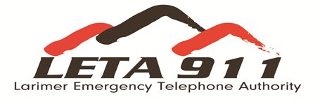

Name:
Locations you want to receive alerts about:
- Address:

- Address:

- Address:

- Address:

- Address:

EMERGENCY ALERT SYSTEM
REGISTRATION FORM

How to Contact me
Home phone:
Work Phone (1):
Work Phone (2):
Cell Phone (1):
Cell Phone (2):
Text:
Text:
Email:
Fax:

Signature:
Date:

Please mail completed form to:
Larimer Emergency Telephone Authority
380 N. Wilson Ave
Loveland, CO 80537

