LETA Board Packet

Meeting Subject: Location:
Larimer Emergency Telephone Authority LETA Office
2024 Public meeting | Budget Hearing 4872 Endeavor Dr Suite 200
Johnstown, CO. 80534

Meeting Contact: Date: Time:
Kimberly Culp 970-962-2175 12/4/2024 0900-1030

AGENDA ITEMS

- CALL TO ORDER | ROLL CALL
Board Chair, Steve Charles calls the meeting to order and completes the roll call of members present.

Steve Charles |  | Chair | Dan Coldiron |  | Director
Joe Shellhammer |  | Vice Chair | Jarrod Poley |  | Director
James Robinson |  | Secretary | Marc Barker |  | Director
Justin Allar |  | Treasurer | Ian Stewart |  | Director

- REVIEW OF THE AGENDA
Review of the agenda and addition of items of new business to the agenda for consideration by the Board.

- PUBLIC COMMENT

Individuals wishing to speak during public comments are welcome and the time allotted per person is 3 minutes.

Comments from the public are allowed during public comment. If additional comment or input is needed before a decision is made, the Board member should move the agenda item to a future meeting to allow additional discussion or a special committee to study the item.

The Board has the right to invite anyone to speak, whom it wishes to hear from, but this must be done by unanimous or majority vote.

At no time shall the public inject comment during the Board meeting or discussion on agenda items.

- FINANCIAL REVIEW

CEO Culp will present the financial report for September and October. No significant changes from October to report.

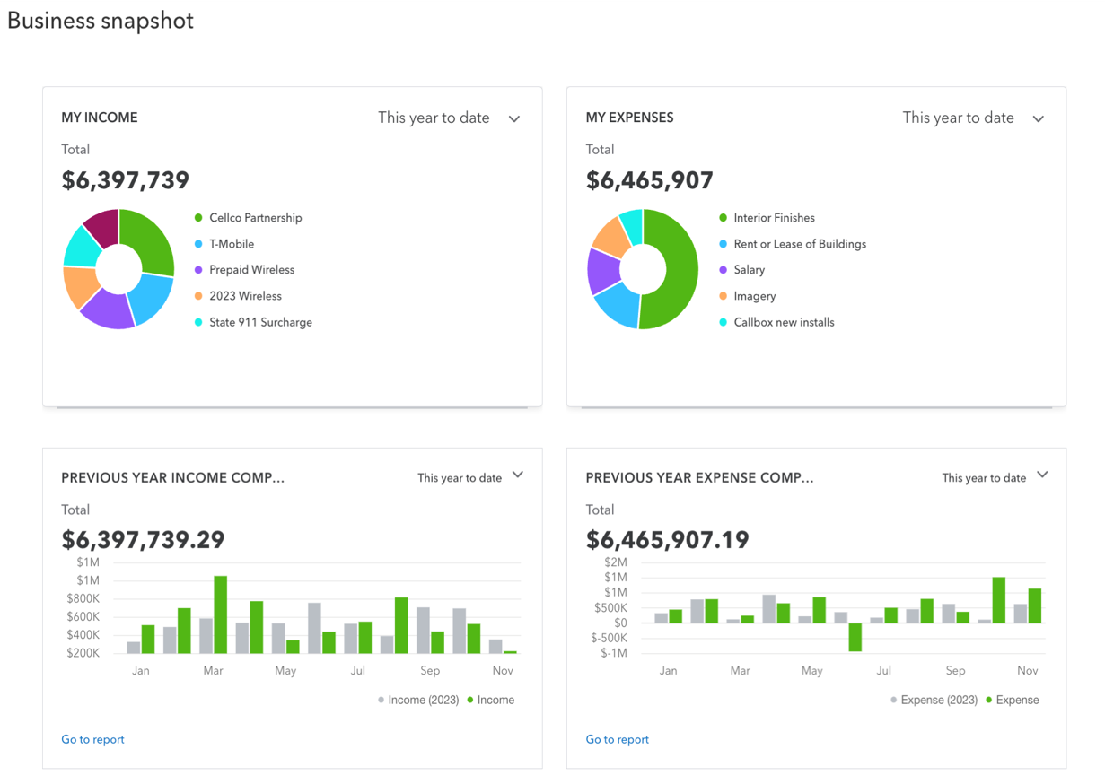
CEO Culp will provide a summary of the Consent Calendar. Specifically, item d and item e. Item d was approved at the October business meeting and includes a small change in CEO Culp’s contract, the LETA Board is asking her to provide a 4-month notice (120 days) if the CEO resigns from her position.

Resolution 2014-13 adopts the LETA Policy Manual with the three additional policies as discussed in October. 1- CRISP Policy, Language translation policy, and EAS process w/ bordering agencies.

- CONSENT CALENDAR
  - Approval of the October 2nd meeting minutes
  - Approval of September and October finance report
  - Approval of September and October deposits and bills report
  - Approval of Resolution 2024-12 CEO Contract
  - Approval of Resolution 2024-13 adopting LETA Policy Manual

BOARD ACTION: Staff Recommends the LETA Board Chair call for a motion to adopt the consent calendar.

- RECOGNITION
  - Operations Administrator Haley Pittman will present information to the LETA Board regarding the ETC Program and the work that Battalion Chief Robert Carmosino has done for the success of the program and the training of new 911 personnel.

- 2025 BUDGET OVERVIEW
  - CEO Culp will provide an overview of the 2025 budget.

The financial items being addressed in the 2025 budget include the finishes for the new facility and the transition to the new building in February / March. In 2025 LETA will continue to furnish the new facility including conference rooms, and the dispatch furniture add ons for the backup PSAP.

The anticipated next tariff process has been opened and LETA is engaged in the discussions. The new tariff again raises our rates with CTL and is the tariff that provides services that are duplicative in nature.

LETA’s new facility also includes two large projects that are critically important; LETA is separating domains from Loveland and moving off their network. LETA is also installing a green field build for the backroom which equates to replacing over 80% of our hardware / servers / on prem and virtual environment. LETA’s focus in the 2025 budget is to close the gap on our infrastructure monitoring and risk testing (internal and external threat analysis).

State budget format document is LETA’s official 2025 budget and is presented by Anderson & Whitney accounting firm.

- PUBLIC HEARING ON THE 2025 BUDGET

The LETA Board Chair opens the floor for the public to comment on LETA’s 2025 Budget.

Comments should be held to 2 minutes per person.

After public comment, the LETA Board Chair closes the floor for public comment.

- ADOPTION OF THE 2025 LETA BUDGET

BOARD ACTION: Staff recommends the LETA Board Chair call for a motion adopting the 2025 budget.

- BOARD ACTION
  - Appropriation Resolution
After the 2025 budget adoption, the LETA Board has established the funds allocated for the Lease of the LETA Facility (Endeavor Dr). The Appropriation Resolution identifies the amounts required for payment to BBVA /PNC for the lease payments.

Staff Recommendation: The LETA Board Chair calls for a motion to approve the Appropriation Resolution.

  - Radio Funding
The LETA Board has received a request to fund the radio consoles in the PSAPs. - 64 consoles between the 7 PSAPs

The LETA Board of Directors has discussed the funding question during the October 2023 retreat, during the April 2024 Strategic Planning session, and again during the October 2024 retreat.

Concerns discussed by the LETA Board
- LETA, historically, has not funded radios. Radios were not an eligible expense in title 29, article 11 when LETA was formed and when the CRS changed to allow radios, the LETA Board was not interested in making a change in the funding philosophy.

- The amount of money required to fund radio consoles is significant and a significant budget impact to LETA.

Support for as discussed by the LETA Board
- Funding radios is not a unique ask for a 911 Board. Most 911 Authority Boards fund [and oversee] Phones/Radios/and CAD along with various programs that support public safety response.

- LETA can use their negotiation powers through their contacts and through the CCOA to receive greater discounts. Ie.. larger purchasing power buying and negotiating one contract for 64 consoles vs 7 different contracts.

- Some partner agencies are facing budget hardships in the next 2 fiscal years.

Staff Recommendation: This is a philosophical funding question for the Board of Directors. The Board legally can fund radios and shift this capital purchase, capital replacement, and ongoing maintenance to LETA.

LETA’s Staff is confident they can add this equipment, maintenance contract, and workload. LETA Staff is also confident they can work within agencies current radio structure to ensure a successful transition or minimal transition depending on the needs of the agency.

For the budgetary impacts, LETA’s CEO is responsible to ensure the direction of the LETA Board is prioritized while maintaining funding levels and fully supporting programs that fall under LETA’s purview. As with tax revenue, 911 surcharge is estimated annually based on behavior of our community members, population growth, and service providers. We monitor, watch for trends, determine recession impacts, and other external factors that can threaten the local surcharge revenue like tariff increases.

LETA is also monitoring increases for equipment and maintenance contracts and making those adjustments in advance to be prepared for capital replacement and program needs.

For outside funding, LETA is always looking for grant opportunities, efficiencies in cost sharing, regional opportunities, and partnerships. LETA has been the recipient of 4 grants:
1 - NG911 Grant in 2013 225k
2 - Building grants in 2020 1.5m
- CRD Grant in 2023. 70k

LETA’s accounting team prepared a study to review the possible financial impacts to the LETA budget if a capital expenditure for radio consoles is added in 2027 and 2028.

Raw spreadsheet

Staff recommends the Board Chair to entertain motions regarding the funding of radio consoles so LETA’s partner agencies can plan accordingly.

- OLD BUSINESS
  - HR Update: on schedule. Transition is occurring December 15th.

  - Building Update: on schedule, under budget, 7k. LETA will be moving the backup PSAP the month of February, moving LETA office in March, and turning the floor over to the State and Interagency Dispatch in April.

- NEW BUSINESS
  - National Park Service (NPS) Contracting with LETA
The NPS is interested in contracting with LETA and to become a secondary PSAP under LETA’s umbrella of support and oversight. NPS has secured funding through the Rocky Mtn Conservancy (RMC).

In progress:
- Legal document regarding the arrangement (contract/IGA/etc)
- Budget for initial costs
- Budget for ongoing costs and ongoing agreement of costs if RMC funding does not get allocated (annual basis).
- Timeline: approval in February
- Project would begin if approved by the LETA Board in February.

- STAFF COMMUNICATION

- LETA BOARD COMMUNICATION

- ADJOURN BUSINESS MEETING AND ENTER INTO EXECUTIVE SESSION FOR TWO ITEMS:

Jackson County IGA Issue: Motion to go into Executive Session under Colorado Revised Statute § 24-6-402(4)(b) for the purpose of receiving advice from the Board’s legal counsel regarding Section VII of LETA’s Fifth Amended Intergovernmental Agreement and Jackson County’s obligations thereunder, and under Colorado Revised Statute § 24-6-402(4)(e) to determine the Board’s position on matters regarding Section VII(2) of LETA’s Fifth Amended IGA that may be subject to negotiation, developing strategy for negotiation, and instructing negotiators.

Sheriff Poley may not participate in this portion of the Executive Session due to his conflict of interest.

LETA’s PUC Complaint against CenturyLink: Motion to go into Executive Session under Colorado Revised Statute § 24-6-402(4)(b) for the purpose of receiving advice from the Board’s legal counsel regarding the remedies LETA seeks against the BESP and under Colorado Revised Statute § 24-6-402(4)(e) to determine the Board’s position on matters in PUC Proceeding No. 24F-0470T that may be subject to negotiation, developing strategy for negotiation, and instructing negotiators.

- ADJOURN EXECUTIVE SESSION

- REJOIN BUSINESS MEETING

- ADJOURN BUSINESS MEETING

2025 Meeting Schedule

February 5th 0900-1030 LETA – 4872 Endeavor Dr
April 2nd 0900-1030 LETA – 4867 Venture Dr
June 4th 0900-1030 LETA – 4867 Venture Dr
August 6th 0900-1030 LETA – 4867 Venture Dr
October 1st 0900-1500 LETA – Retreat @4867 Venture Dr
December 3rd 0900-1030 LETA – 4867 Venture Dr

2024 Board Member Terms

Justin Allar | Treasurer | 01/01/2023 | 12/31/2024 – 2nd term
Marc Barker | Director | 10/01/2023 | 12/31/2026 – 1st term
Dan Coldiron | Director | 01/01/2024 | 12/31/2025 – 3rd term
Joe Shellhammer | Vice Chair | 01/01/2025 | 12/31/2026 – 2nd Term
James Robinson | Secretary | 01/01/2025 | 12/31/2026 –2nd Term
Steve Charles | Chair | 01/01/2024 | 12/31/2025 – 8th term
Ian Stewart | Director | 01/01/2024 | 12/31/2025 – 1st term
Jarrod Poley | Director | 11/01/2023 | 12/31/2025 – 1st term
Tracy Oldemeyer | Legal Counsel | N/A | N/A
Kimberly Culp | Chief Executive Officer | N/A | N/A
Prashant Thapaliya | GIS Technician | N/A | N/A
Val Turner | Chief of Staff | N/A | N/A
Ben Butterfield | GIS Manager | N/A | N/A
OPEN | System Admin | N/A | N/A
OPEN | System Admin | N/A | N/A
Bekah Rumfelt | GIS Analyst | N/A | N/A
Haley Pittman | Operations Admin | N/A | N/A
David Clarke | Operations Admin | N/A | N/A

