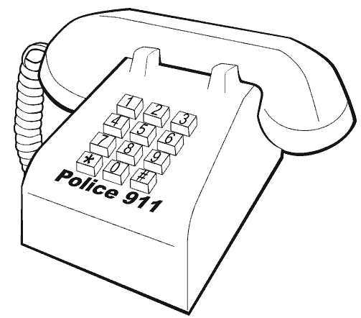
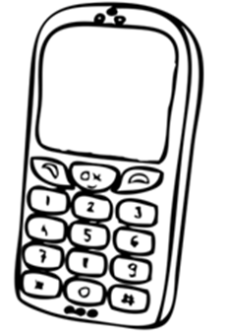

MY NAME:________________________
MY ADDRESS:_____________________
MY CITY OR TOWN:________________
MY PHONE NUMBER:_______________
MY SCHOOL:______________________

